**SOLUTION DESIGN DOCUMENT**

**Intelligent Support Copilot Bot**

Version v1.2

Revision History

|  |  |  |  |
| --- | --- | --- | --- |
| Date | Revision | Author | Description |
| 07-10-2024 | V1.0 | Ravi Teja, Ragam | SDD |
| 21-11-2014 | V1.1 | Ravi Teja, Ragam | SDD |

Table of Contents

Revision History 1

Distribution 3

1 Introduction 4

1.1 Overview 4

1.1.1 Business Requirement 4

1.1.2 Process Description 4

1.1.3 Features of Bot 4

1.1.4 Prerequisite 4

1.2 Proposed Solution 4

1.3 Scope 4

2 Contacts 5

3 Quick Facts 5

3.1 Idea Assessment 5

3.2 Project 6

4 Architecture 6

4.1 Overview 6

4.2 Flow Diagram 6

5 Solution Components 7

5.1 Create the Co-Pilot using Microsoft Co-Pilot Studio 7

5.2 Train the Created Co-pilot with the Required Data 8

5.3 Create the Topics in Copilot 8

5.4 Power Automate Flow Integration 10

6 Data 10

7 Regulatory Requirements 10

8 Security 10

8.1 Risks and Mitigation 11

8.2 Solution Metrics 11

8.3 License Estimation 11

8.4 Triggers 11

8.5 Business 11

8.6 Technical 11

# Distribution

The information has restricted distribution and viewing within Chanel.

Document Version Control

|  |  |  |  |
| --- | --- | --- | --- |
| Date Issued | Version | Description | Author |
| 07/10/2024 | V1.0 | SDD | Ravi Teja, Ragam |
| 21/11/2024 | V1.1 | SDD | Ravi Teja, Ragam |

Document Sign-off Requirements (NA)

The following table contains the people required to sign-off and/or review this document and those that require the document for information only.

|  |  |  |
| --- | --- | --- |
| Name | Department | Responsibility |
|  |  |  |
|  |  |  |
|  |  |  |

# 1 Introduction

## 1.1 Overview

### 1.1.1 Business Requirement

To automate the process of creating incidents for unsatisfactory chatbot responses and assigning them to available team members within the support system using Power Platform Solution.

### 1.1.2 Process Description

As part of this automation, we will implement a chatbot that interacts with users to address their queries. If a user is not satisfied with the chatbot's response, the chat bot will automatically generate an incident ticket containing the original query. Then this ticket will be assigned to an available team member for further review and resolution, ensuring that user concerns are promptly addressed and documented.

### 1.1.3 Features of Bot

* The chatbot will interact with users and capture their queries.
* If a response is deemed unsatisfactory, an incident ticket will be automatically generated.
* The incident ticket will include details such as the user's original query.

### 1.1.4 Prerequisite

* Microsoft Copilot Studio development environment.
* Microsoft Graph API access.
* Power Automate license.

## 1.2 Proposed Solution

Hence, to automate the process of managing incidents for unsatisfactory chatbot responses, the team proposes implementing a Power Platform solution that automatically generates incident tickets when user express dissatisfaction. The Chat Bot will capture the user’s original query, assigning the ticket to an available team member for resolution. Notifications will be sent to both the user and the assigned team member to ensure timely follow-up, streamlining the entire process and enhancing user satisfaction.

## 1.3 Scope

* Region: APAC
* Markets: Global
* Staff: IT Unit
* Data Files: NA

# 2 Contacts

|  |  |  |
| --- | --- | --- |
| Key Contacts | Email ID | Role |
| Dilip Thankappan | dilip.thankappan@capgemini.com | Phoenix RPA SC Lead |
| Ravi Teja, Ragam | ragam.ravi-teja@capgemini.com | Phoenix Power Platform Developer |

# 3 Quick Facts

### 3.1 Idea Assessment

|  |  |
| --- | --- |
| Topic | Value |
| Business Unit  *(1. Fashion, 2. Fragrance and Beauty, 3. WFJ)* | 3 |
| Use Case  *(Automation, Mobile/tablet App, Web Portal, Workflow, Chatbot,* *IDP, ML/AI, Others)* | *Chatbot* |
| Impact on Business  *(Business Critical, Not Business Critical)* | Not Business Critical |
| Users  *(Individual or Small Team, Large Team or Service, Department or Region)* | Individual or Small Team |
| Power Platform Features  *(Power Automate, Power Apps, Power Virtual Agents, Power* *BI, Power Automate Desktop,* *AI Builder)* | Power Automate, Microsoft Copilot Studio, Power Virtual Agents |
| Power Platform Connectors  *(List of Power Platform Connectors)* | HTTP Connector, Teams, SharePoint, Office 365 connector |
| System Interactions | Microsoft Copilot, Graph API |

### 3.2 Project

|  |  |
| --- | --- |
| Topic | Value |
| Project Type  *(GYRB)* | R |
| Environments  *(GYRB)* | R |
| Licensing | Microsoft 365 E5 |
| Track  *(Business Project, Citizen IT)* | Business Project |
| External Partner* | NA |

*\* Business Projects only*

# 4 Architecture

## 4.1 Overview

To effectively address user concerns about unsatisfactory chatbot responses, the team proposes an automated solution that generates incident tickets whenever users indicate dissatisfaction. The chatbot captures the user’s original query, leading to the immediate creation of an incident ticket using power automate. This ticket is then assigned to an available team member for swift resolution. This streamlined process enhances responsiveness, ensuring user issues are addressed promptly and improving overall satisfaction with the support system.

## 4.2 Flow Diagram

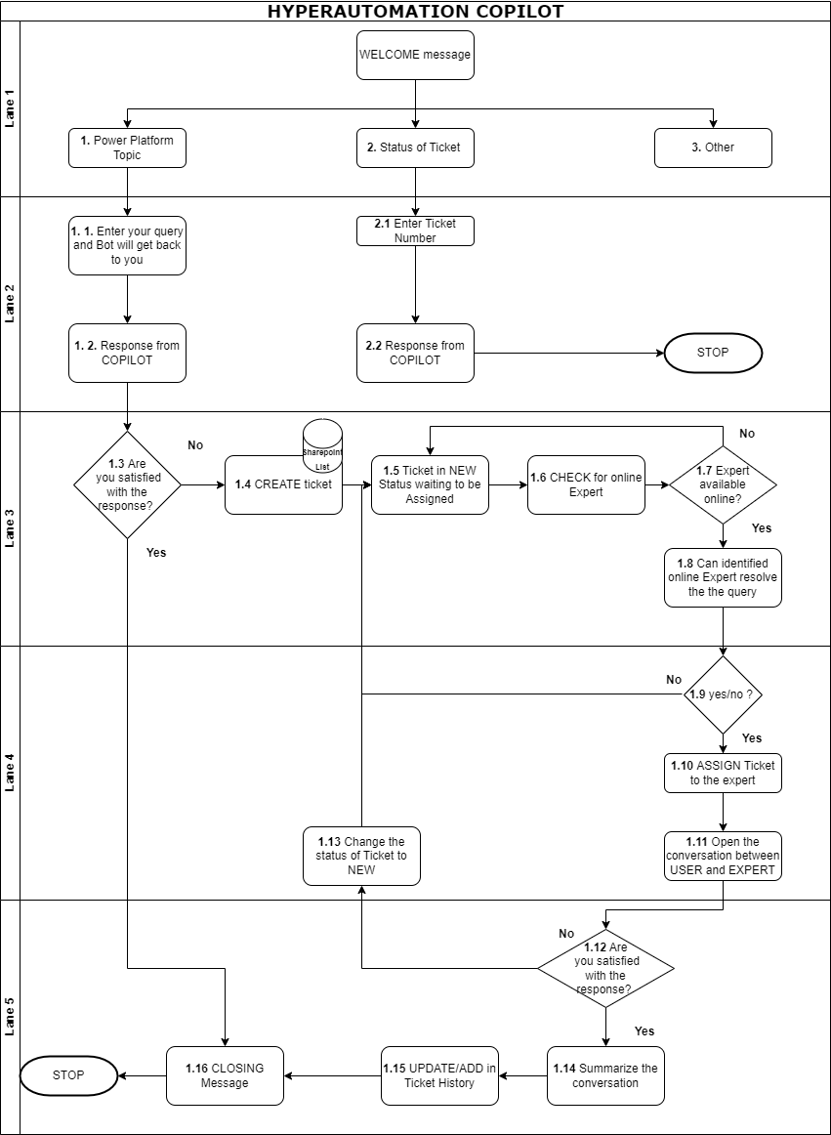

**Diagram 1.0**: Flow Diagram for Intelligent Support Copilot Bot

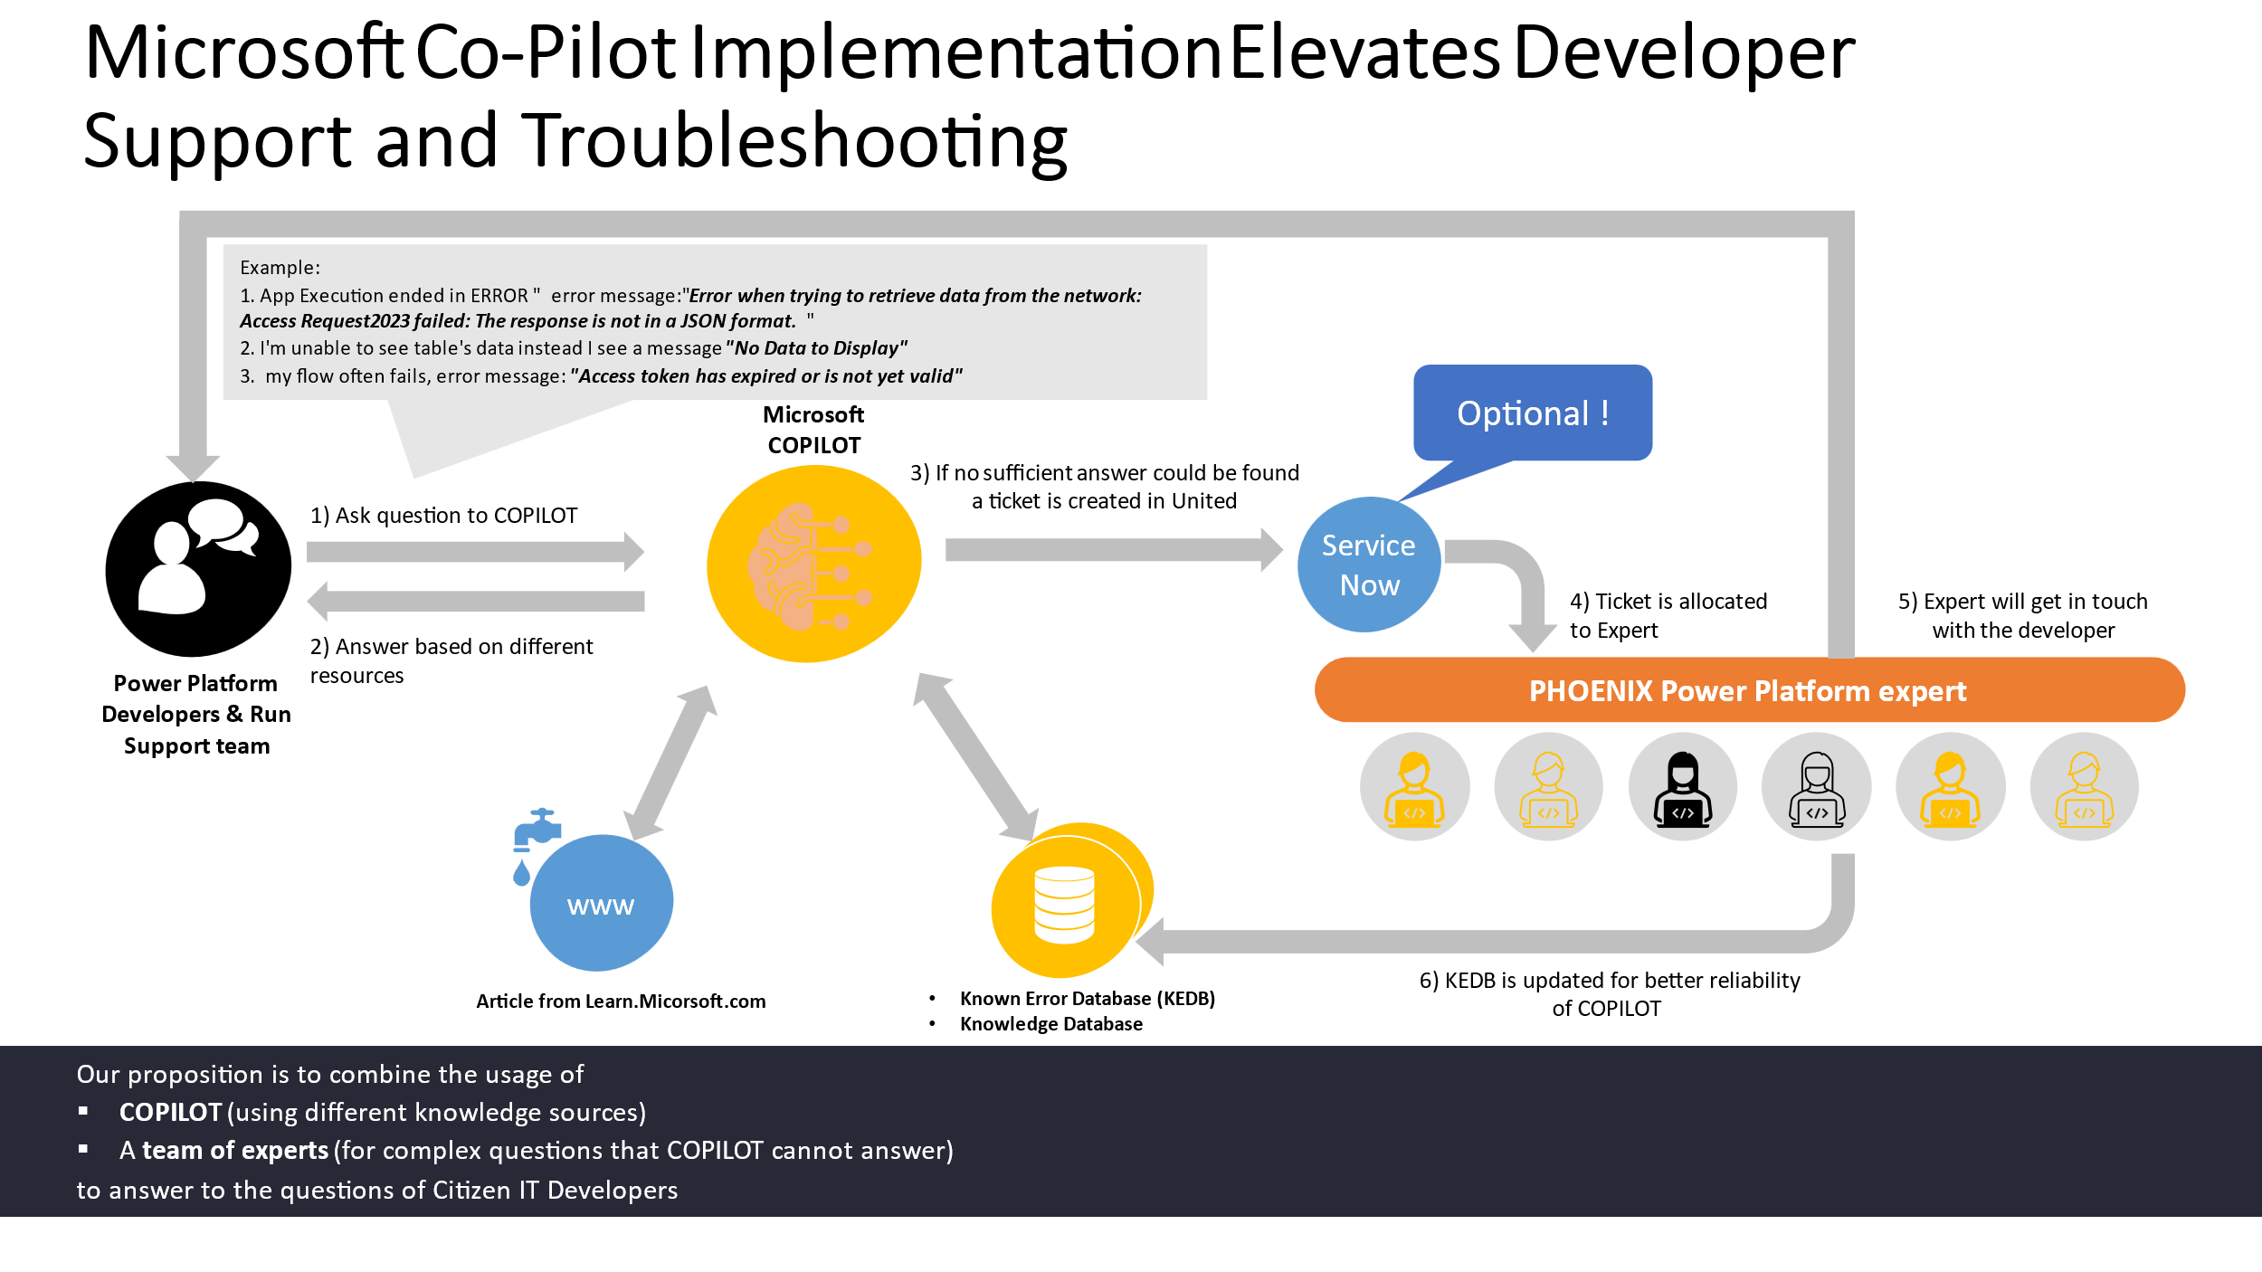

**Fig: Solution Design Workflow for Service Intelligent Support Copilot Bot**

# 5 Solution Components

The following steps will be performed in the process.

## 5.1 Create the Co-Pilot using Microsoft Co-Pilot Studio

Initially, create the Co-Pilot by providing the Name, Icon, Description and Instructions of the Co-Pilot in Overview Tab.

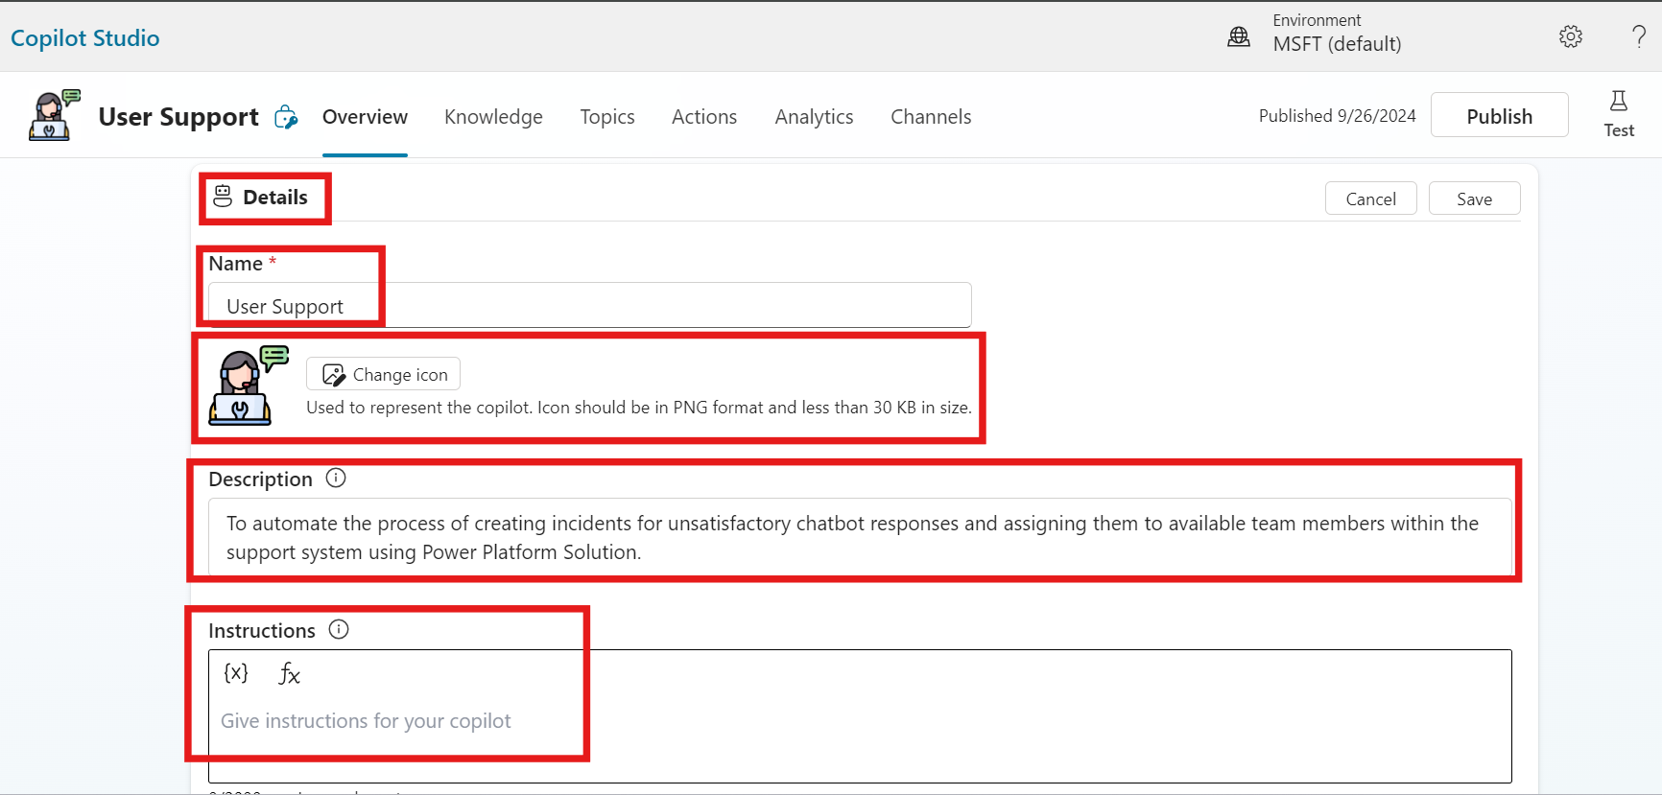

***Fig: Basic Required things for the Copilot in Microsoft Copilot Studio***

## 5.2 Train the Created Co-pilot with the Required Data

* Once Overview is completed, Add the Knowledge in Knowledge Tab. Train the Copilot with the necessary data to ensure it provides accurate and relevant responses to user queries.

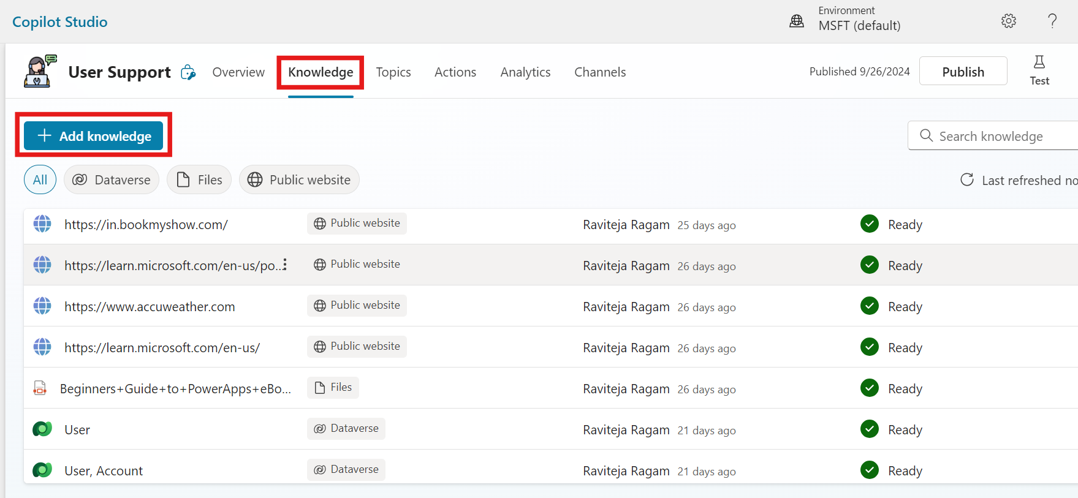

***Fig: Added some Knowledge for this Copilot***

## 5.3 Create the Topics in Copilot

* After Knowledge, add the topic for the Co-Pilot. Train the Copilot with the necessary data to ensure it provides accurate and relevant responses to user queries. Need Detailed Explanation.

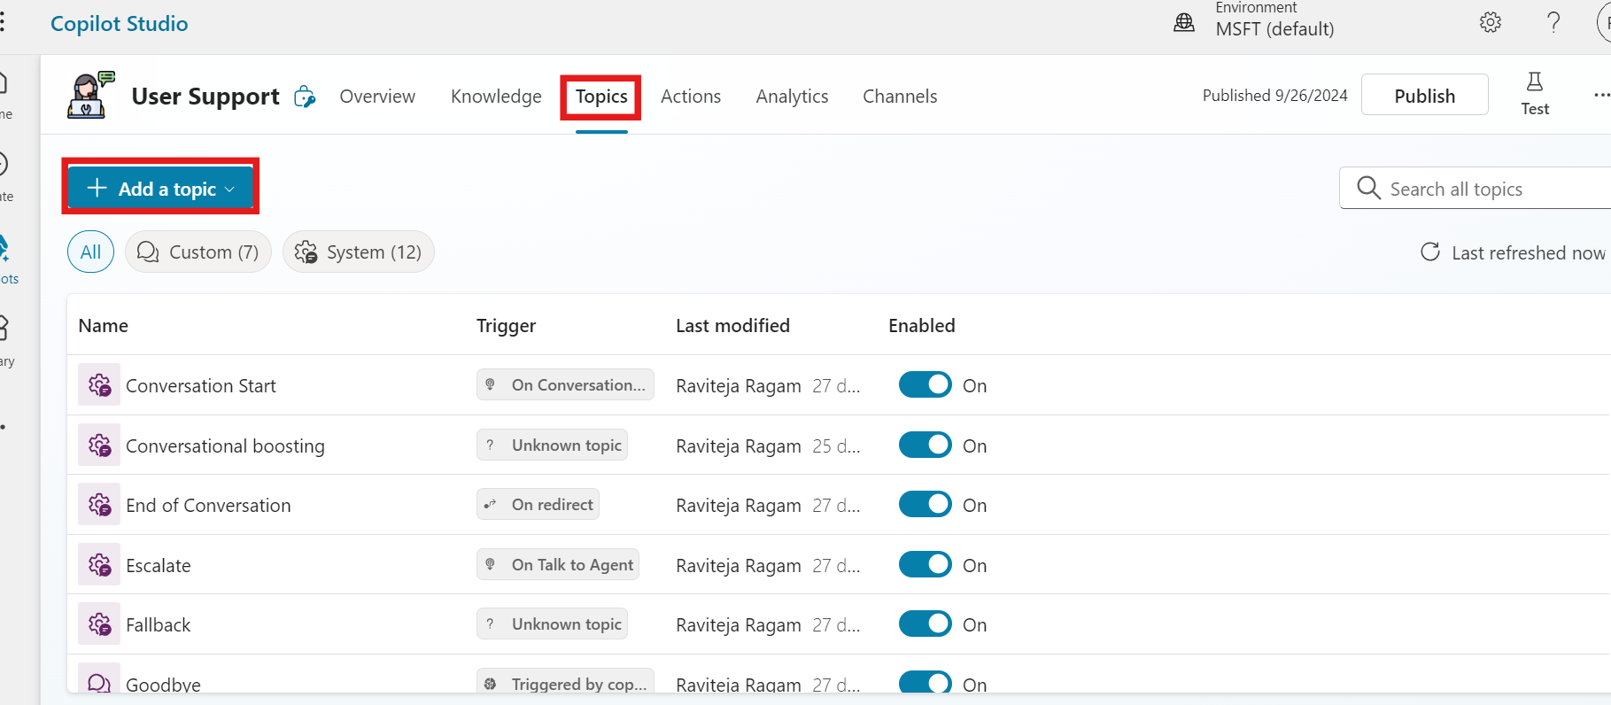

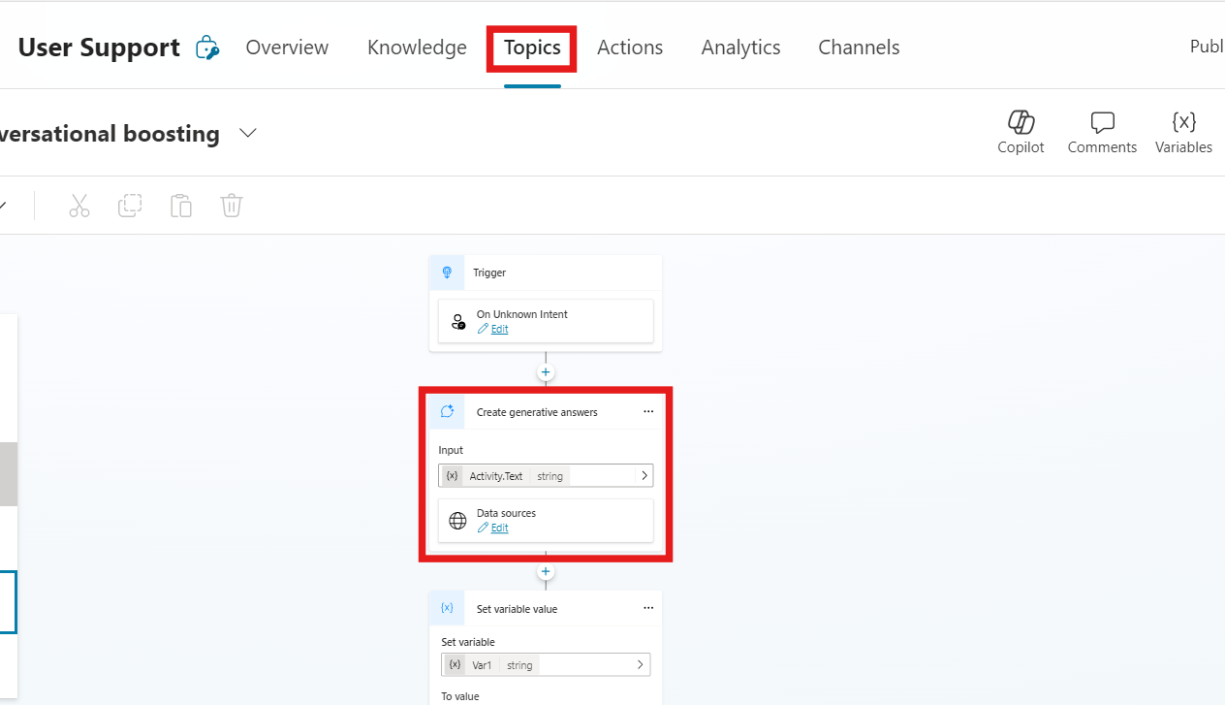

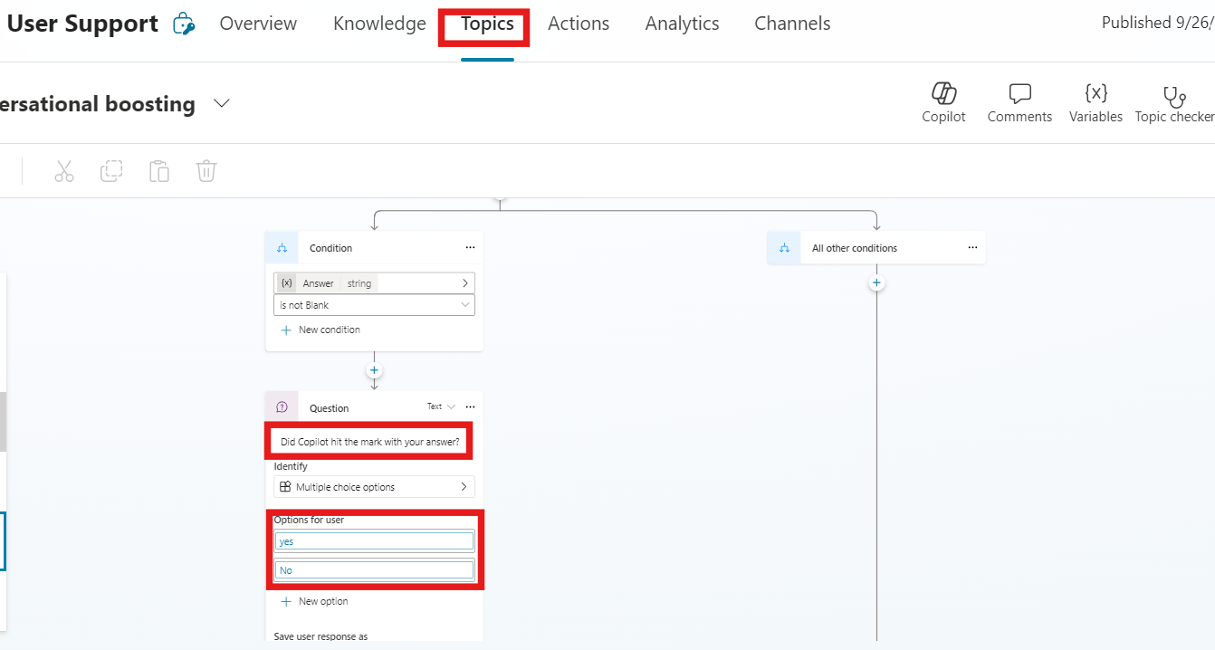

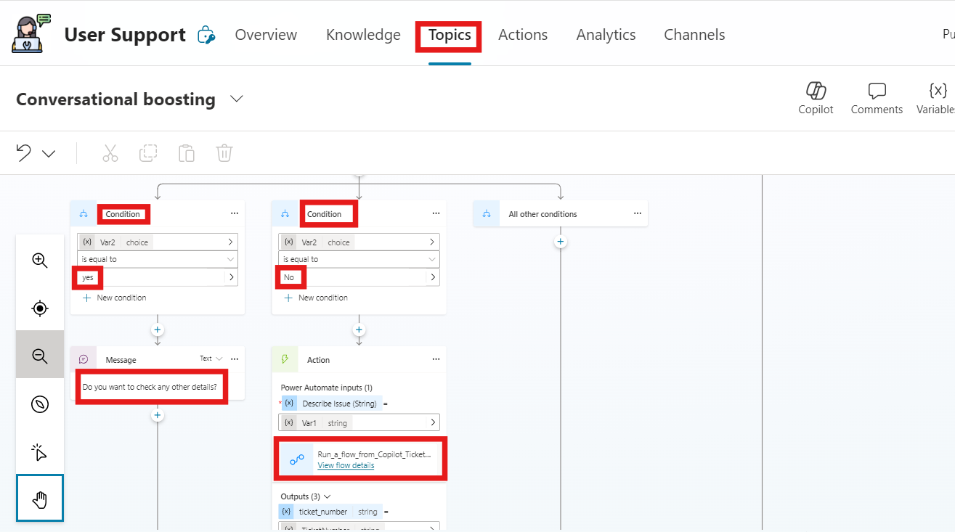

***Fig: Copilot Topics in Microsoft Copilot Studio***

## 5.4 Power Automate Flow Integration

Configure a Power Automate flow that is triggered when a user expresses dissatisfaction (i.e. No).

* Create an incident ticket and send the ticket ID back to the user.
* Utilize Microsoft Graph API to identify available team members from the designated group or team.
* Assign the incident ticket to an available team member and send a notification message to the assignee and user via Microsoft Teams.
* With that message, link will be shared to both assignee and user to chat. By clicking the link, they can start their chat to resolve the ticket.

Need that message image

* After the ticket is resolved, the user has updated the question asked in the chat. Once it is said “yes”, then the ticket will be added to Ticket history and status updated as completed.

Need that message image

* If “No”, then the status will be updated as new, and cycle begins.

Need that message image

# 6 Data

*NA*

# 7 Regulatory Requirements

*NA*

# 8 Security

*NA*

## 8.1 Risks and Mitigation

*<Brief overview on how the different stakeholders interact with the solution, what are the risks associated and the mitigation actions for those risks>*

## 8.2 Solution Metrics

## 8.3 License Estimation

## 8.4 Triggers

When a service request is created in ServiceNow.

## 8.5 Business

*<List all know business exceptions, per task, that are expected for the solution. Each exception should include details such as the task, exception description, affected applications and manual actions needed to solve issue either by Business or Support teams>*

## 8.6 Technical

*<List all know system exceptions, per task, that are expected for the solution. Each exception should include details such as the task, exception description, affected applications and manual actions needed to solve issue or to alert the person/team that can solve the issue>*